Forecasting Takeover in LLM Agent Populations: Preregistered Tests of Policy Emulators and the Limits of Early Warning

Sharath M Shankaranarayana
Synthpop.AI
With
Apart Research
Abstract
A small committed minority can tip a population of LLM agents into a new convention, an abstraction of a few compromised agents hijacking swarm norms. Large-population estimates of the required critical mass rely on emulators driven by policies extracted from the model, but these forecasts are rarely tested prospectively. In an LLM naming game, we run three preregistered live forecasting tests (DeepSeek-v4-flash; 83 populations; 146k decisions) and diagnose errors against exact log-probability policies of three open-weight models. Live decisions match the offline policy samples closely on average (RMS difference: estimated 95% upper bound 0.024), although small deviations near the threshold can shift individual forecasts. A forecast from a policy pooled across word pairs failed and showed no improvement over a constant reference. Exact policies explain why: averaging the transition policy across contexts yields a far sharper transition than the mixture of populations (flip-probability error up to 0.37), and the smoothed estimators we tested bias critical mass low by up to 60% at small sample sizes, with posterior intervals that rarely cover the truth. Target-conditional forecasts correctly predicted a large directional asymmetry (10/10 vs 2/10 takeovers), and a third forecast, published before its runs on new populations of a previously explored target pair, passed its preregistered tests (7/8 vs 0/8 takeovers; 4/4 cells inside predictive intervals), though a direction-only rule scores almost as well (Brier 0.06 vs 0.05). In emulation, calibrated early-warning indicators added no consistent discrimination beyond population level and trend.

1. Introduction
Populations of interacting LLM agents can self-organise into collective behaviour that no single-agent evaluation anticipates; the July 2026 Hugging Face incident is a recent example [16]. A concerning failure mode is norm hijacking: a handful of agents that never update can, through ordinary repeated interaction, pull a population onto a convention of their choosing. In the classical committed-minority model this happens once the adversarial fraction exceeds a critical mass [8, 9], and recent work reproduces such tipping points with LLM agents [1–5].
An overseer wants to know how many agents an adversary must control and whether a takeover can be seen coming. Because live experiments are expensive, large-population answers rely on emulators: simulations driven by policies extracted from the LLM [2–4]. Prior work validated per-pair, log-probability emulators against direct LLM simulations [2, 3] and mapped directional, convention-dependent critical masses across models [3]. What has not been done is to forecast prospectively: freeze an emulator’s numerical predictions, then test them on new live populations, and diagnose the errors. This matters most for black-box APIs that expose no log-probabilities, where the policy must be estimated from samples and choices about aggregation and smoothing are unavoidable.
Threat model. An adversary controls c of N agents (committed fraction p = c/N) that always play a target convention B, or poisons agents’ memories at a hidden rate q(t). The adversary may choose which convention to push. The defender can query the model offline and observe the population’s aggregate behaviour.
Contributions.
- Three preregistered forecasting tests. An emulator built from a policy pooled across word pairs failed and showed no improvement over a constant reference; a target-conditional emulator correctly forecast a large directional asymmetry and improved proper scores; and a third, externally timestamped forecast confirmed a directional prediction on new populations.
- A decision-level check of the policy-following assumption for a sampled (no-logprob) API model, with calibrated inference, power analysis, and the consequence for the forecast quantity.
- A controlled diagnosis of forecast error against exact policies: aggregation across contexts versus sampling and smoothing, with bias, RMSE and interval coverage of the critical-mass estimate.
- A level-matched, surrogate-calibrated evaluation of early-warning indicators for an emulated memory-poisoning driver, as a bounded secondary result.

2. Related Work
Conventions and committed minorities in LLM populations. Ashery et al. [1] showed that LLM populations form conventions that committed minorities can overturn, noting that the tipping point depends on the conventions involved. Flint et al. extracted per-pair log-probability policies, validated the resulting model against direct LLM simulations, and studied group size [2]. Their indirect tipping study [3] showed quantitatively that critical masses are directional and convention-dependent across four models, forming a directed graph over equilibria. Passaro et al. [4] reused those per-pair policies to reach 10³–10⁵ agents across topologies and excluded conditions whose convention is unstable with zero committed agents. De Marzo et al. [5] report conformity-driven misalignment and hysteresis; De Nobili et al. [6, 7] give statistical-physics descriptions of LLM populations. Target dependence, emulator validation with log-probability policies, and the stability precondition are therefore established. Our contribution is complementary: preregistered numerical forecasts tested on new live populations, a validation for a sampled policy from an API without log-probabilities, and a controlled account of how estimation and aggregation choices propagate into critical-mass forecasts.
Early warning and multi-agent risk. Critical slowing down [10, 11] is used to anticipate transitions, but conditioning on transitions inflates apparent performance [12]; indicators can also be learned [13]. Hammond et al. [14] catalogue multi-agent risks, and Makins et al. [15] show that per-instance monitors miss distributed attacks.

3. Methods

3.1 Environment and definitions
We adapt the naming game of Ashery et al. [1] , N = 24 agents start on convention A. Each round agents are paired by a uniformly random perfect matching, and each pair plays a coordination game (+100 if both choose the same word, −50 otherwise). An agent’s prompt contains only its last five records (own word, partner’s word, payoff); we remove the cumulative score of the original prompt so that no hidden state remains. Option order is shuffled per call, reasoning is disabled (0 reasoning tokens verified), and output is JSON with one resample on parse failure (0 unrecoverable failures in 146,097 live calls over the three tests; 121,423 in Tests 1–2). c committed agents always play B.
The observable f_{t} is the fraction of non-committed agents playing B. A population flips if the two-round mean of f_{t} reaches 0.5 within 150 rounds: a finite-horizon first-passage event for a given N, horizon, initial state and event definition, not a statement about an asymptotic bifurcation. φ(p) is the flip probability and the critical mass p_{c} solves φ(p_{c}) = ½. Emulator flip probabilities are Monte Carlo estimates (≥ 300 runs; SE ≤ 0.03; 1,000 runs, SE ≤ 0.016, for frozen predictions). The flip event agreed with sustained adoption (f_{t} ≥ 0.9 for 5 rounds) in 97–100% of live runs (§4.4).
The prompt is a deterministic function of the memory states (2¹⁰ = 1024 states), word pair w and option order o. Because order is randomised per call, the population dynamics are driven by the order-marginalised policy π(s, w) = E_{o} P(B | s, w, o); an emulator with the true π(s, w) reproduces the live protocol up to Monte Carlo error.

3.2 Policy extraction and emulators
API model (DeepSeek-v4-flash). No log-probabilities are exposed, so π is estimated by sampling: 8 samples per state cycling through six word pairs, plus 40–48 extra samples on near-threshold states, and pair-specific top-ups for the two pairs of Test 2. Local models (Qwen3-8B, Gemma-3-12B, Mistral-7B, Llama-3.1-8B; 4-bit MLX community builds on an Apple M5 Pro). We compute next-token probabilities of the two words after a forced {"value": " prefix, renormalised over the two answers and tempered to T = 0.7 (the untempered next-token distribution puts ≥ 97% of its mass on the two answers), for all 1024 states × 6 pairs × 2 orders. We call these exact policies: exact for this forced-prefix two-answer policy of these quantised builds, not for unrestricted generation. We compare pooled (π averaged over pairs) vs target-conditional (π for one pair) emulators, and unsmoothed maximum-likelihood estimates k/n vs Jeffreys (k + ½)/(n + 1) and Laplace (k + 1)/(n + 2) estimates.

3.3 Preregistered live tests
Before each live experiment we recorded SHA-256 hashes of the preregistration, code, policies and predictions (the documents are available from the author; hashes establish content identity, not independent chronology). Test 1 used the pooled DeepSeek policy and counterbalanced word pairs by seed (pair allocation was therefore not balanced within every level of c). H1: at every level of c the live flip count lies inside the emulator’s 95% predictive interval (PI), evaluated by an interval rule and a Holm-corrected binomial rule. Test 2 (addendum) used target-conditional policies for “push Q” (A = M, B = Q) and “push M” (A = Q, B = M) with fixed words and fresh seeds. The primary H5 is directional: flips(push M) > flips(push Q) at c in {3, 4} (one-sided Fisher exact test); H1′ repeats the PI check. PIs were built from Jeffreys-Beta posterior draws of the policy, which §4.3 shows to be biased; we treat this as a limitation and add proper scores against baselines.
Test 3 (added after independent review) forecasts the X/Y pair in both directions on new populations; this pair was already explored post hoc in Test 1 (3 populations per direction), which motivated its selection. It uses target-conditional unsmoothed policies and parametric-bootstrap PIs. Design: c in {3, 4} (the levels with the largest predicted difference between directions), 4 new populations per cell, 100-round horizon. H6 (primary): the predicted-easier direction flips more often (one-sided Fisher); H7: the frozen predictions beat a leave-one-out constant reference in Brier score (cell-stratified paired bootstrap CI excludes 0); H8: all cells inside 95% PIs. A planned second live model (gemma-4-31b) was infeasible before the deadline under the provider’s rate limit.

3.4 Monitoring evaluation (emulation)
The hidden driver is memory poisoning: each round each agent’s new record is forged (partner recorded as playing B) with probability q(t). In emulation with N = 48 (not the N = 24 of the live tests), TOWARD runs ramp q from 0 to 1.6·q_{c} over 300 rounds; 4,700 null runs per policy are generated over stationary, stop-short and away-ramp schedules, of which the 4,345–4,402 that never tip are used. Segments ending L in {10, 25, 50, 100} rounds before the tip are matched 1:1 to null segments on final level and trend. Indicators are variance and lag-1 autocorrelation (AC1) converted to surrogate-calibrated z-scores, plus level, trend, recent slopes and an oracle that observes q. Incremental value is the grouped cross-validated logistic AUROC of level + trend with and without the indicators. Uncertainty uses a cluster bootstrap over connected components of matched pairs that share a null run (fixed out-of-fold predictions); H4 decisions (indicators add ≤ 0.02 AUROC) use this cluster bootstrap. A refit bootstrap (one CV repeat per replicate, whereas point estimates average five) is a sensitivity analysis for the calibrated indicators only. This is a retrospective discrimination task on selected pre-tip segments, not a prospective alarm.

4. Results

4.1 Live decisions versus the extracted policy
We reconstructed the context of 121,375 first-attempt live decisions (67 populations) and compared them with 38,948 offline samples of the same model. Estimand: the live-decision-weighted mean squared difference between live and extracted choice probabilities over (word pair, state) cells with ≥ 2 observations per side (eligibility uses counts only). With a per-cell noise-corrected estimator, it is ≈ 0 (−0.00003 ± 0.0003; 1,691 cells, 120,575 decisions), i.e. an RMS difference with 95% upper bound 0.024. Uncertainty is a jackknife that deletes one live population at a time plus grouped deletion of extraction samples. In 60 simulated replications of a simplified experiment (the real population design, visitation and stopping, but one policy pooled over word pairs and fixed extraction counts), its 95% intervals covered the realised discrepancy 60/60 times, for perturbations scaled to nominal RMS 0 and 0.02 (the realised decision-weighted RMS differs slightly; Clopper–Pearson lower bound 0.94). This supports the procedure in these simulations, not yet for the full pair-specific, adaptively extracted design. A population bootstrap with replacement, which we tried first, failed this check (0/40) because duplicated decisions bias the noise correction.
An exploratory homogeneity test against an independent-Bernoulli reference (not modelling adaptive visitation) nonetheless rejects equality (p ≈ 0.006–0.03; simulated false-positive rate 0.045, power 0.94 for an exact 0.01 shift). The departure is concentrated in a few mid-probability states of the M → Q pair (e.g. live 29/33 vs extraction 10/24 choosing B), not in rare transitions (cells with pooled p < 0.05 or > 0.95 contribute 19% of the statistic). In a post-hoc plug-in sensitivity analysis, substituting live estimates in states with ≥ 5 live decisions changed the emulated critical mass by 0.0002 (pooled), 0.002 (push Q) and 0.013 (push M, a 11% relative change), but changed the flip probability at single levels by up to 0.02, 0.06 and 0.31, respectively. Live agents deviate detectably but slightly on average from the extracted policy; near a steep threshold such small deviations can move individual-level forecasts substantially.

4.2 Preregistered test 1: a pooled emulator fails near threshold
The pooled-policy emulator predicted p_{c} = 0.135. Table 1 compares its predictions with 32 live populations.
Table 1. Preregistered test 1 (DeepSeek-v4-flash, N = 24). k = number of populations that flipped. H1 requires k to lie inside the emulator’s 95% predictive interval.
c | p | Live flips | Emulator φ | 95% PI (k) | H1
2 | 0.083 | 1/4 | 0.00 | [0, 0] | fail
3 | 0.125 | 4/8 | 0.11 | [0, 5] | pass
4 | 0.167 | 5/8 | 0.97 | [7, 8] | fail
5 | 0.208 | 8/8 | 1.00 | [8, 8] | pass
8 | 0.333 | 4/4 | 1.00 | [4, 4] | pass
H1 is rejected under both preregistered rules. The c = 4 failure is robust (P(k ≤ 5 | φ = 0.962, n = 8) ≈ 0.003); the c = 2 failure rests on a single run. Scored with the frozen predictions, the pooled forecast showed no improvement over a constant reference (leave-one-out base rate): Brier 0.220 [0.108, 0.336] vs 0.229, paired difference 0.009 [−0.127, 0.137], i.e. neither better nor demonstrably equivalent; log-loss 0.82 vs 0.65. Post hoc, outcomes at c = 2–4 tracked the committed word (push M 5/5, push Q 0/5; Fig. 1), and re-predicting each run with its own pair’s unsmoothed policy reduced the Brier score to 0.09. (Pair allocation also varied across levels; §4.3 isolates pooling.)
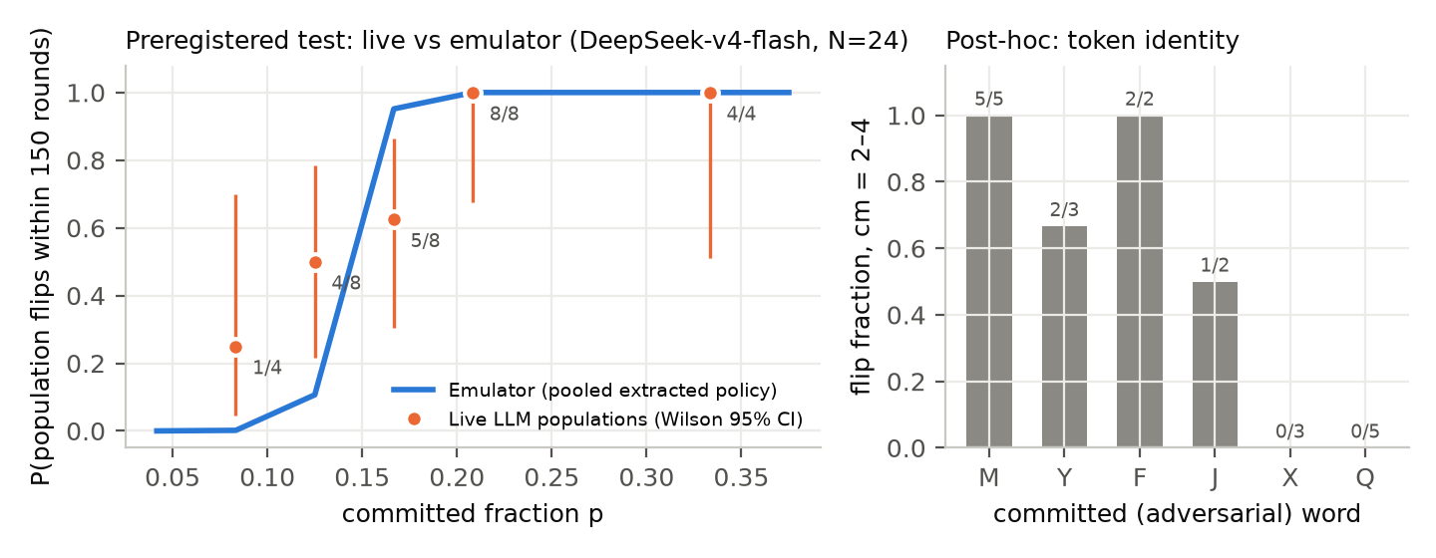
Figure 1. Preregistered test 1. Left: live flip fraction (Wilson 95% CI) vs the pooled-policy emulator. Right (post hoc): flips at c = 2–4 split by the committed word.

4.3 Diagnosing forecast error with exact policies
Precondition. Llama-3.1-8B does not hold a convention without adversaries (P(B | five successful A rounds) up to 0.95; spontaneous flips in 5/6 pairs) and is excluded, following the stability criterion of [4]. Qwen, Gemma and Mistral showed 0 spontaneous flips in 1,200 runs each (95% upper bound on the per-run rate 0.25%).
Target dependence (replication). Consistent with [1, 3], p_{c} depends on the pushed convention (Table 2); pushing Q from M is the hardest target in all three models and in DeepSeek live.
Aggregation. Averaging the transition policy across pairs is not the same as averaging population outcomes across pairs. The pooled emulator happens to land near the mixture’s p_{c} here (e.g. Qwen 0.272 vs 0.270), but its transition is far sharper: maximum flip-probability error 0.20–0.37 (Table 2). A mixture of sharp, target-specific transitions is broad, which matches the Test 1 failure pattern.
Estimation. We re-ran sampled extraction in silico with a fixed, balanced target mixture (K a multiple of 6: K/6 samples per pair and state), 30 replicates per K. The unsmoothed estimator’s critical mass was nearly unbiased even at K = 6 (bias −0.005, +0.006 and −0.001 for Qwen, Mistral and Gemma; RMSE 0.013–0.023), whereas Jeffreys (bias −0.08 to −0.11) and Laplace (−0.15 to −0.20) estimates were strongly biased low at small K, with bias shrinking as K grows (Jeffreys −0.005 to +0.000 at K = 120). Interval calibration (nominal 90%, 40 extraction replicates, Clopper–Pearson CIs on coverage) differed sharply. A parametric bootstrap that collapses counts to a single binomial per state covered the true p_{c} in 29–38/40 (K = 12) and 34–37/40 (K = 48) replicates; a design-preserving stratified bootstrap (per pair) covered only 25–31/40 and 32–33/40, because two to eight samples per pair cannot represent transitions never observed (each interval used only 20 draws and 80 simulated populations per threshold point, so fine differences between methods are uncertain); and stratified Jeffreys posterior draws covered it in 0/40 at both K. (An earlier pooled-Jeffreys check with 15 replicates gave 0% and 33–53%.) Our preregistered predictive intervals were built from Jeffreys draws and were therefore shifted toward a lower critical mass. These are evaluations of specific approximate procedures, not of smoothing or Bayesian inference in general. Unbiased estimates of each probability need not yield an unbiased estimate of the nonlinear threshold, and a zero count makes the unsmoothed estimate certain that a transition never happens. Neither smoothing nor Bayesian uncertainty propagation is ruled out; the specific posterior-mean estimators we tested are biased at small K.
Table 2. Exact-policy ground truth (N = 24, 150-round horizon). Range of p_{c} across six target conventions; maximum |Δφ| of the pooled emulator relative to the counterbalanced mixture; bias of the critical-mass estimate at K = 6 samples per state (balanced design).
Model | p_{c} range across targets | Hardest target | Pooled max |Δφ| | Bias at K = 6: MLE / Jeffreys / Laplace
Qwen3-8B | 0.23–0.38 | M → Q | 0.20 | −0.005 / −0.084 / −0.151
Gemma-3-12B | 0.25–0.37 | M → Q | 0.20 | −0.001 / −0.112 / −0.198
Mistral-7B | 0.07–0.41 | M → Q | 0.37 | +0.006 / −0.088 / −0.163
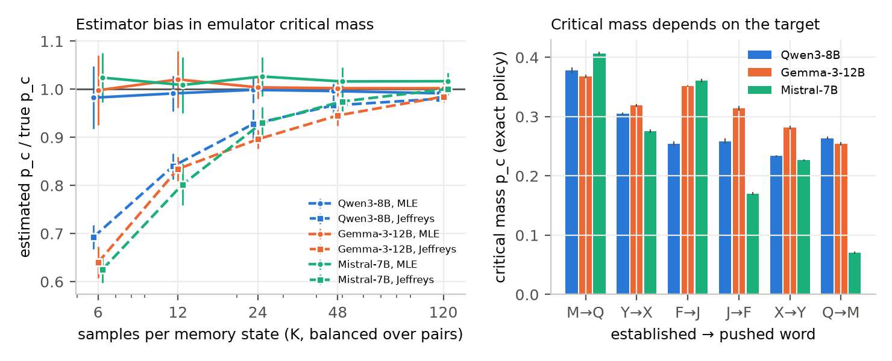
Figure 2. Exact-policy ground truth. Left: estimated / true critical mass vs samples per state in a balanced design (K/6 samples per word pair), mean ± SD over 30 replicates, for unsmoothed (MLE) and Jeffreys estimators. Right: critical mass by target convention (error bars: ±2 Monte Carlo SD over 8 seed sets; all ≤ 0.005).

4.4 Preregistered test 2: a target-conditional forecast
Using target-specific DeepSeek policies, we ran 35 new populations (Table 3, Fig. 3).
Table 3. Preregistered test 2 (DeepSeek-v4-flash, 5 populations per cell). Values are listed per level of c.
Direction | c | Live k/5 | Emulator φ | 95% PI (k)
push Q | 3 / 4 / 5 / 6 | 0 / 2 / 5 / 5 | 0.00 / 0.18 / 0.96 / 1.00 | [0,1] / [0,5] / [4,5] / [5,5]
push M | 2 / 3 / 4 | 1 / 5 / 5 | 0.01 / 0.59 / 1.00 | [0,4] / [1,5] / [5,5]
The directional forecast H5 is confirmed: at c = 3–4, push M flipped 10/10 populations vs 2/10 for push Q (one-sided Fisher p = 3.6×10⁻⁴). It is robust to the event definition (100-round horizon: 8/10 vs 1/10, p = 0.003; sustained adoption: 10/10 vs 1/10, p = 6×10⁻⁵). Quantitative calibration is only weakly tested: H1′ passes (7/7 cells inside PIs), but intervals such as [0, 5] cannot be falsified with five populations. Scored with the frozen predictions (cell-stratified paired bootstrap), the target-conditional forecast reached Brier 0.094 [0.047, 0.160] (log-loss 0.33), better than the frozen pooled forecast (0.224; paired difference 0.13 [0.04, 0.22]) and than a leave-one-out constant reference (0.239; difference 0.145 [0.051, 0.211]); the pooled forecast again showed no improvement over the constant reference (difference 0.015 [−0.061, 0.087]). With 10 vs 10 populations, H5 could detect only large effects (≈ 0.8 vs 0.2).
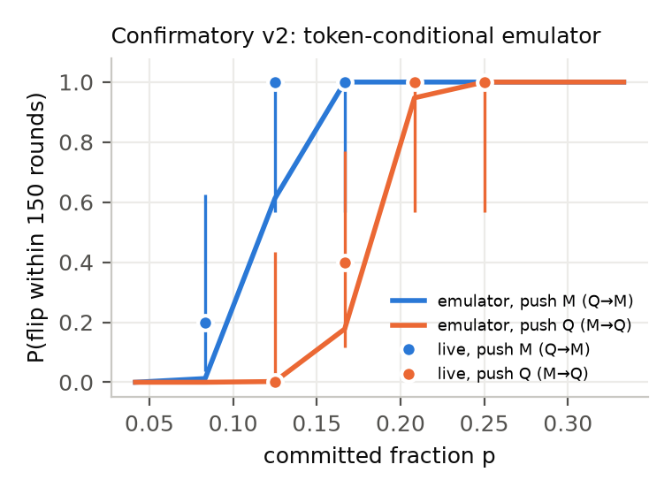
Figure 3. Preregistered test 2: live flip fraction (Wilson 95% CI) vs the target-conditional emulator, for both directions.

4.4b Preregistered test 3: an externally timestamped forecast on new populations
The forecast was published before any live run (§3.3). On 16 new populations (Table 4) all three preregistered hypotheses passed. Directional discrimination (H6): the predicted-easier direction (push Y) flipped 7/8 populations vs 0/8 for push X (one-sided Fisher p = 7×10⁻⁴). Proper score (H7, as preregistered): Brier 0.052 vs 0.280 for a leave-one-out constant reference (difference 0.228, 95% CI [0.116, 0.284]). Calibration (H8): all four cells fell inside their 95% predictive intervals, three of them narrow ([4, 4], [0, 0], [0, 2]). Post-hoc diagnostics qualify H7: a direction-only rule (every push-Y population flips, no push-X population does) scores Brier 0.0625, so the emulator’s numerical advantage over knowing the direction is small (0.010, 95% CI [−0.005, 0.041]); and when cells with identical outcomes are given posterior uncertainty (Beta-drawn cell probabilities), the CI of the improvement over the constant reference widens to [−0.11, 0.28]. Test 3 therefore confirms the directional forecast on new populations; it adds little evidence about precise probabilities (4 populations per cell, same model, previously explored pair).
Table 4. Preregistered test 3 (new populations; push Y: X → Y, push X: Y → X; N = 24; 100 rounds; predictions public before the runs).
Direction | c | Live k/4 | Emulator φ | 95% PI (k)
push Y | 3 / 4 | 3 / 4 | 0.88 / 1.00 | [1,4] / [4,4]
push X | 3 / 4 | 0 / 0 | 0.00 / 0.07 | [0,0] / [0,2]

4.5 Monitoring: no consistent incremental value from the tested indicators
In the preregistered unmatched design, level and trend alone separate TOWARD from null segments almost perfectly (CV AUROC 0.97–1.00), so H4 passes trivially. After level-and-trend matching (Appendix E, Fig. 4), level and trend are uninformative (AUROC ≈ 0.50) while an oracle that sees the poisoning rate reaches 0.87–1.00 at leads of 25–50 rounds, so information about the driver exists beyond level and trend. Calibrated variance and AC1 indicators alone reach 0.43–0.58 with no consistent sign; their incremental value over level + trend ranged from −0.17 to +0.05 AUROC, with cluster-bootstrap CIs of about ±0.05–0.06 (no significant gain) and refit-sensitivity CIs of ±0.08–0.12. H4 is not falsified for the calibrated indicators, but equivalence within 0.02 is not established; the preregistered raw variance indicator formally fails H4 for Gemma at lead 50 (+0.099 [+0.045, +0.149]), its calibrated counterpart does not (+0.039 [−0.013, +0.089]). The tested indicators showed no consistent incremental discrimination in this retrospective, emulated (N = 48, pooled-policy) task; we did not evaluate prospective alarms.

5. Discussion and Limitations
For forecasting swarm vulnerability. For this sampled API model, live decisions tracked the extracted policy closely on average, but small deviations moved individual-level forecasts near the threshold; this is one model and one prompt. The decisive errors were in how the policy was used: averaging transition policies across contexts gave a confidently wrong, too-sharp transition, and the posterior-mean estimators we tested made populations look easier to take over at small sample sizes. Forecasts should be target-conditional [1, 3], estimators should be checked for bias and coverage against a known policy, and uncertainty should be able to represent unseen transitions. For monitoring, the tested indicators added nothing consistent beyond population state and trend; the oracle result points to the driver itself (e.g., integrity checks on agent memories) as the more promising signal.

Limitations
One live API model (a second was infeasible under the rate limit); N = 24 live (48 in monitoring emulation); 4–8 populations per level; one abstract game, memory length, temperature and label set; reasoning disabled; no claim about the Hugging Face incident beyond motivation. DeepSeek policies are sampled; local policies are exact only for the forced-prefix two-answer policy of specific 4-bit builds. Tests 1–2 PIs used biased Jeffreys draws; Test 1 pair allocation was unbalanced; post-hoc per-pair analyses used samples partly collected after Test 1. Monitoring is retrospective, emulated, with pooled policies and one driver.

6. Conclusion
A pooled-policy forecast failed, while target-conditional forecasts confirmed a large asymmetry, including an externally timestamped directional forecast on new populations. Exact policies trace the failure to aggregation across contexts and biased small-sample estimators: forecasts should be target-specific, estimator-checked and prospective.

Code and Data
Code, tests, sanitized decision-level data (results/decisions/), policies, predictions and analysis outputs: https://github.com/sharath-sms/Swarm-Alignment-Hackathon-Apart-Research. Test 3’s preregistration is public in prereg/ (pushed before its runs). Ashery et al. [1] data used under MIT licence.

Author Contributions
Sharath.M.S. conceived the project, designed and ran all experiments, performed the analysis and wrote the report.

References
- Ashery, A. F., Aiello, L. M., & Baronchelli, A. (2025). Emergent social conventions and collective bias in LLM populations. Science Advances, 11, eadu9368.
- Flint, A., Aiello, L. M., Pastor-Satorras, R., & Baronchelli, A. (2026). Group size effects and collective misalignment in LLM multi-agent systems. Proceedings of the National Academy of Sciences, 123, e2531697123.
- Flint, A., Aiello, L. M., Constantino, S. M., Pastor-Satorras, R., & Baronchelli, A. (2026). Indirect tipping: a social attack surface in AI agent populations. arXiv:2609.25194.
- Passaro, Flint, A., Pastor-Satorras, R., Baronchelli, A., & Aiello, L. M. (2026). Network topology shapes consensus and vulnerability in LLM populations. arXiv:2610.31165.
- De Marzo, G., Bellina, A., Castellano, C., Priesemann, V., & Garcia, D. (2026). Conformity generates collective misalignment in AI agents societies. arXiv:2605.10721.
- De Nobili, C., et al. (2026). Collective alignment in LLM multi-agent systems: disentangling bias from cooperation via statistical physics. arXiv:2605.10528.
- De Nobili, C., Iyer, V., Codello, A., & Burioni, R. (2026). Microscopic dynamics of consensus formation in multi-agent LLM naming games. arXiv:2608.02178.
- Xie, J., Sreenivasan, S., Korniss, G., Zhang, W., Lim, C., & Szymanski, B. K. (2011). Social consensus through the influence of committed minorities. Physical Review E, 84, 011130.
- Centola, D., Becker, J., Brackbill, D., & Baronchelli, A. (2018). Experimental evidence for tipping points in social convention. Science, 360, 1116–1119.
- Scheffer, M., et al. (2009). Early-warning signals for critical transitions. Nature, 461, 53–59.
- Dakos, V., et al. (2012). Methods for detecting early warnings of critical transitions in time series illustrated using simulated ecological data. PLoS ONE, 7, e41010.
- Boettiger, C., & Hastings, A. (2012). Early warning signals and the prosecutor’s fallacy. Proceedings of the Royal Society B, 279, 4734–4739.
- Bury, T. M., et al. (2021). Deep learning for early warning signals of tipping points. Proceedings of the National Academy of Sciences, 118, e2106140118.
- Hammond, L., Chan, A., Clifton, J., et al. (2025). Multi-agent risks from advanced AI. arXiv:2502.14143.
- Makins, O., Angelini, O., Shams, Z., & Phuong, M. (2026). Multi-agent AI control: distributed attacks hamper per-instance monitors. arXiv:2607.07368.
- METR (2026). OpenAI–Hugging Face incident investigation. https://metr.org/blog/2026-08-26-openai-hugging-face-incident-investigation/

Appendix

A. Exploratory analyses: withdrawn and downgraded claims
In the Ashery et al. Claude archive [1], a censored survival fit strongly prefers a threshold law over no-threshold dilution (ΔAIC = 38; p_{c} = 0.156 [0.144, 0.162]), and time-to-takeover rises steeply near the threshold (restricted mean to 800 interactions: 202 at c = 5, 464 at c = 4, 753 at c = 3). We initially reported an exponent γ = 0.53 as evidence for saddle-node scaling (γ = ½). We withdraw this claim: parameter recovery shows that the estimator returns 0.58–0.70 on emulators with known saddle-nodes, exact Qwen/Gemma policies give γ ≈ 0.86/1.05, and large-N simulations show no single exponent (Fig. 5). In the same archive, Llama-3-70B (N = 48) holds its convention without adversaries but tips with a single committed agent (p = 0.02) in 16/21 runs; its threshold lies below the tested range. We also withdraw an earlier “less excess variance before tips” result, which came from the uncalibrated variance indicator.
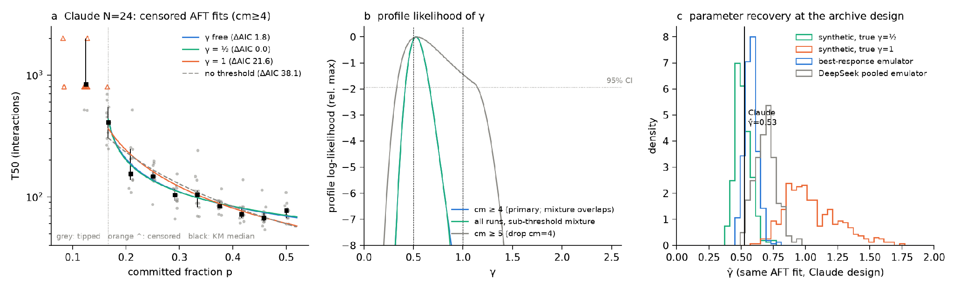
Figure 5. Claude archive (exploratory). a: censored accelerated-failure-time fits; b: profile likelihood of γ; c: parameter recovery at the archive design.

B. Dual-use and ethical considerations
Dual use. Target choice changes the number of compromised agents required, and memory poisoning tips populations; an attacker could use this to choose easier targets. We judge the marginal uplift low: the setting is an abstract coordination game, convention dependence of critical mass is already published [1, 3], and the practical findings are defensive (how to forecast vulnerability and check forecasts). We release a research simulator, not attack tooling. Data and ethics. No human subjects were involved. The Flint et al. group-size repository (no licence file) was not used.

C. Research integrity
All failed preregistered predictions (H1 in Test 1; P5; raw-variance H4 for Gemma) and withdrawn claims (γ = ½; reduced pre-tip variance; an earlier uncalibrated “statistically indistinguishable” agreement claim) are reported. All code, data collection and analysis were done during the sprint (6–8 November 2026); the only pre-existing assets are the public Ashery et al. dataset and code (MIT), whose prompt we adapted.

D. Monitoring pipeline validation
Pipeline validation. On synthetic systems the pipeline detects a fold against a mean-drift null (AUROC 0.95) and does not fire on mean drift alone (0.54). A preregistered check (P5: a level-only baseline cannot separate fold from mean drift) failed (0.62). The raw binomial-normalised variance is biased on pure noise when the mean moves (Kendall τ up to +0.4–0.7), so we recalibrated it with surrogates; residual bias remains when the mean accelerates faster than the detrending window, i.e. just before a tip.

E. Monitoring: level-matched results
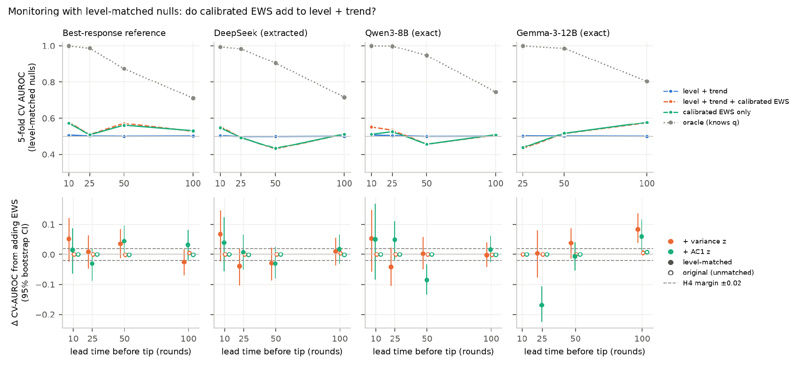
Figure 4. Level-matched monitoring (emulation, N = 48; four policies). Top: CV AUROC of level + trend, level + trend + calibrated indicators, indicators only, and an oracle that knows the poisoning rate. Bottom: ΔAUROC from adding each indicator (95% cluster-bootstrap CI over connected components of matched pairs); dashed lines mark the H4 margin ±0.02.

LLM Usage Statement
Claude was used for coding, analysis, and drafting of this report. All results and claims were checked by the author against the experiment outputs, and the author takes full responsibility for the content.

